1. In PostgreSQL, when we publish a widget, it creates a separate Homepage folder for that widget. As a result, the widgets are only visible within their folder only.

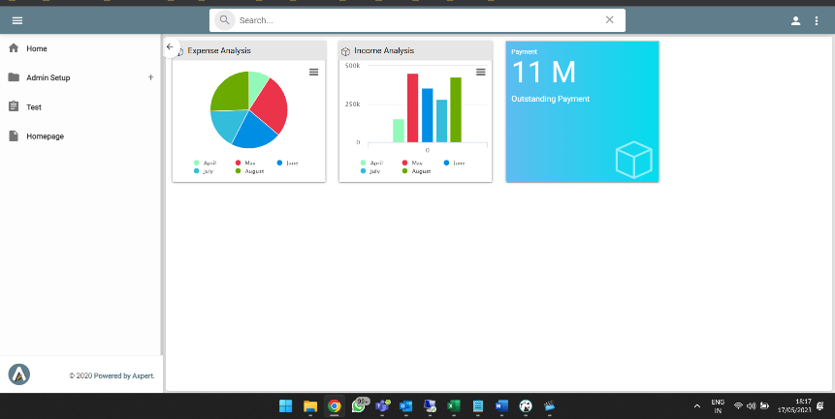

1. In Oracle database, as the widgets are correctly shown within the default home folder itself.

