To reproduce the issue:

1. Log in to the application.

2. Navigate to the Employee Info screen.

3. Search for the employee with the username "L0153" and load the data.

4. Click on the Attachments tab and select the CRP.jpg file.

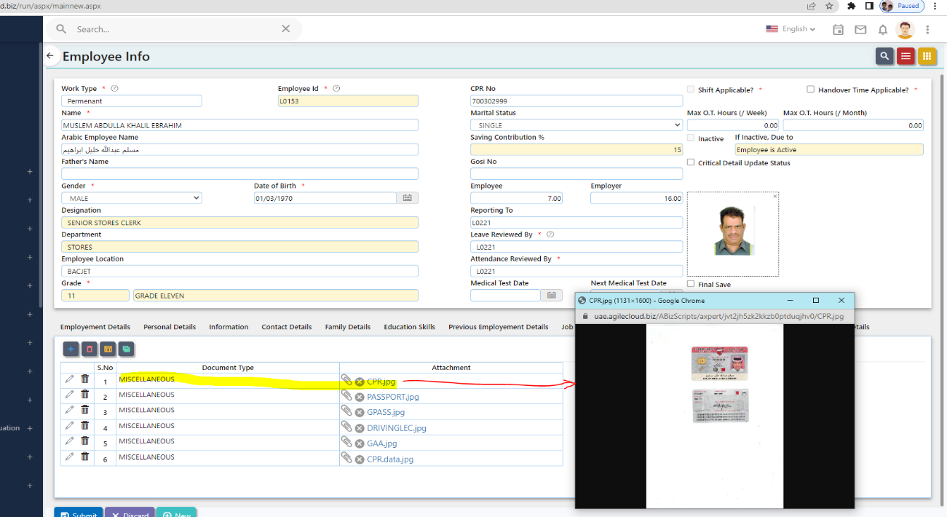

 5. Now search for employee id = L0183 and load the data

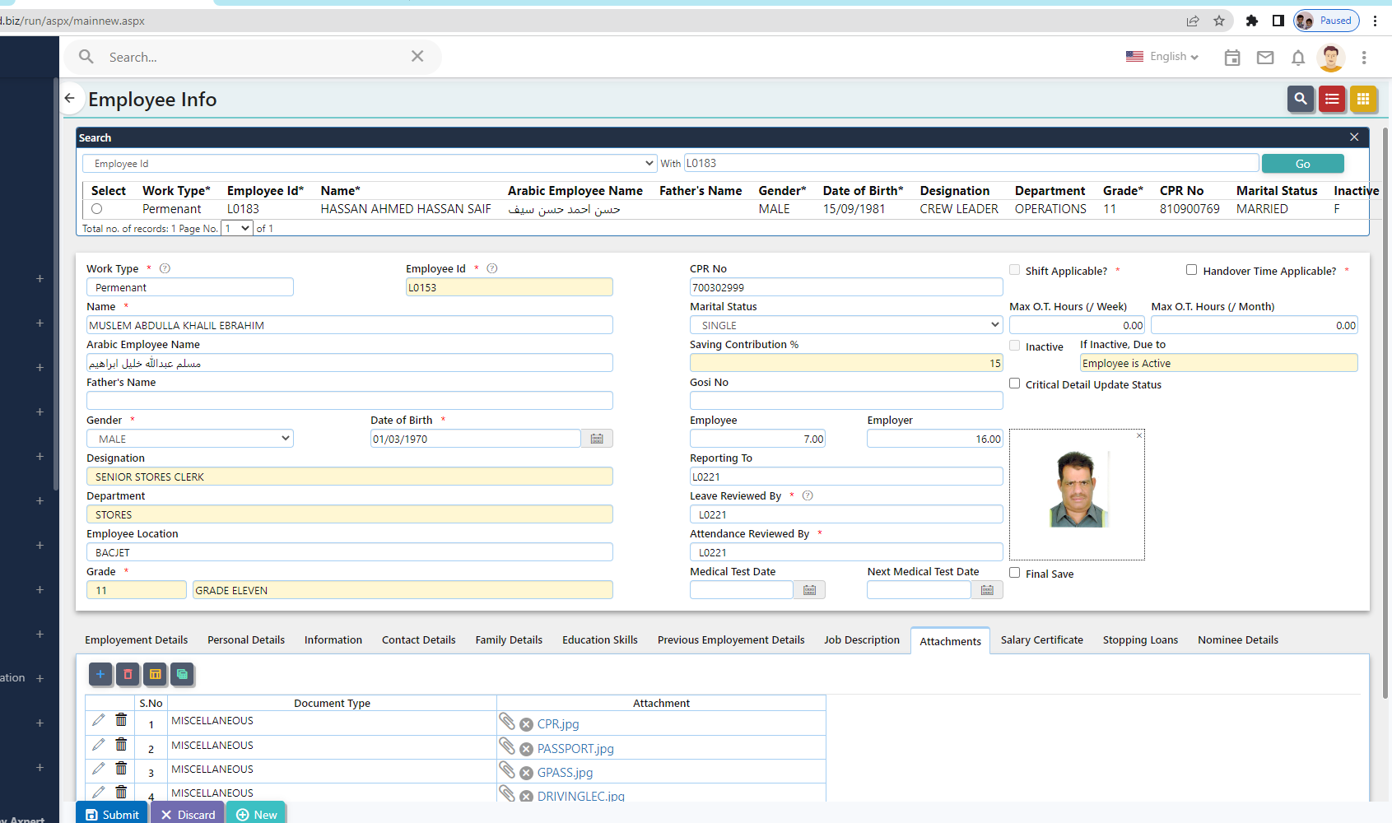

6.Click Attachments tab and click CRP.jpg( same filename opened with user L0153)

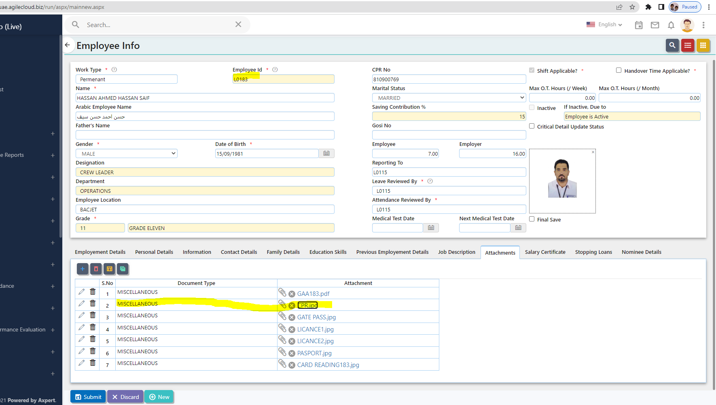

Issue: L0153 username image is popping up when I try to load L0183 CRP.jpg.