If request sent to more than 1 person.

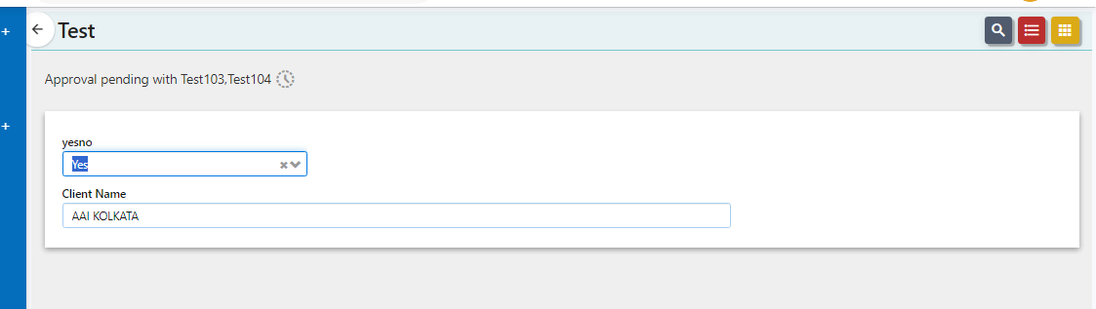

If request sent to a single person.
