Without userid,password we can't edit other settings.

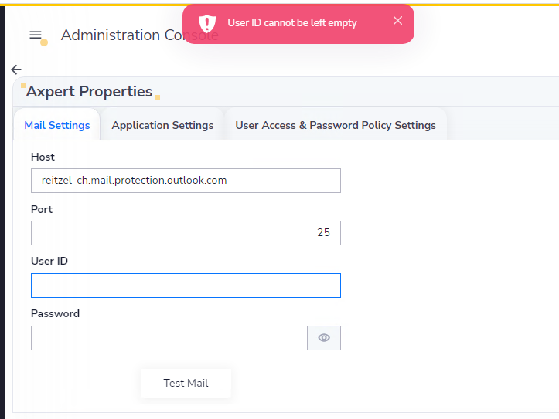

On the same Desktop 10.9 fix-7 without USER ID, PASSWORD Changes applied. Its working fine

