Dynamic filter is working fine in desktop but not working in web. Also, in web columns are not getting displayed properly. Please refer the below screen shot

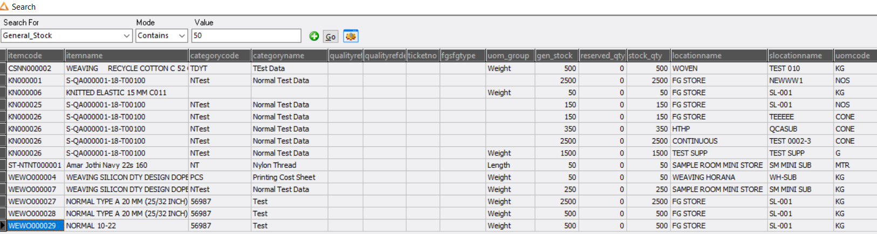

In web, columns are not displaying as in desktop and also not filtering based on the condition mentioned.

