Step1, we created Excel Import action and button in Axpert 11.2 exe

Step 2, Then we traying to do in go online we are getting error.

Step 3, But action button is showing in web run instance.

Step 4, When we will click on that button, we are getting error.

Step 5, We are trying to take trace file but it showing empty.

Step1 image

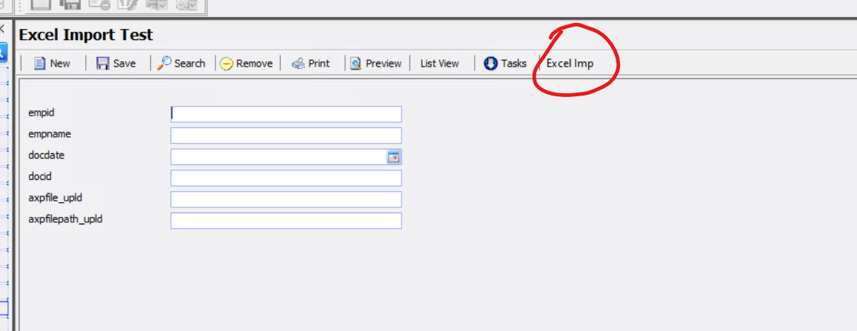

Step 2 image

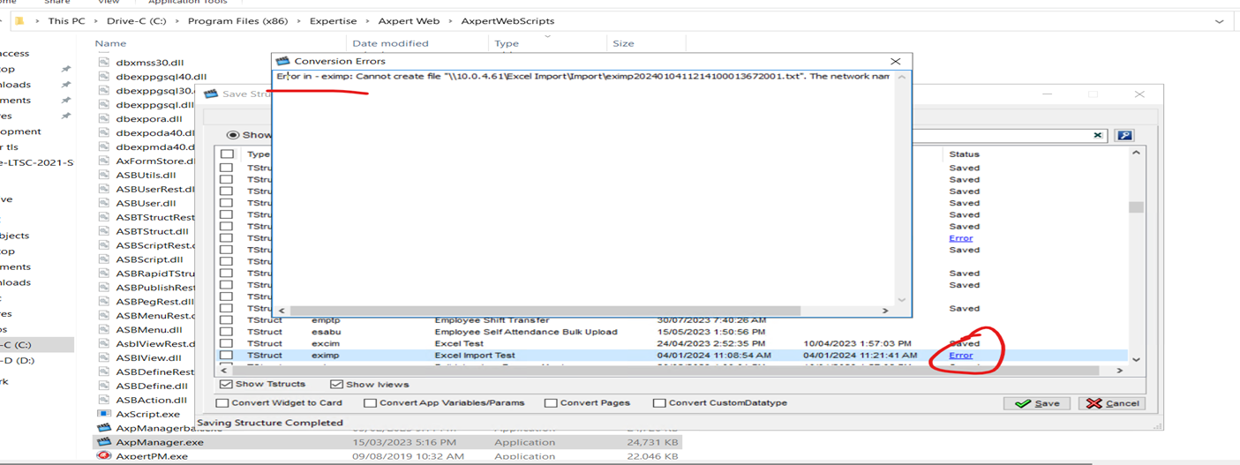

Step3 image

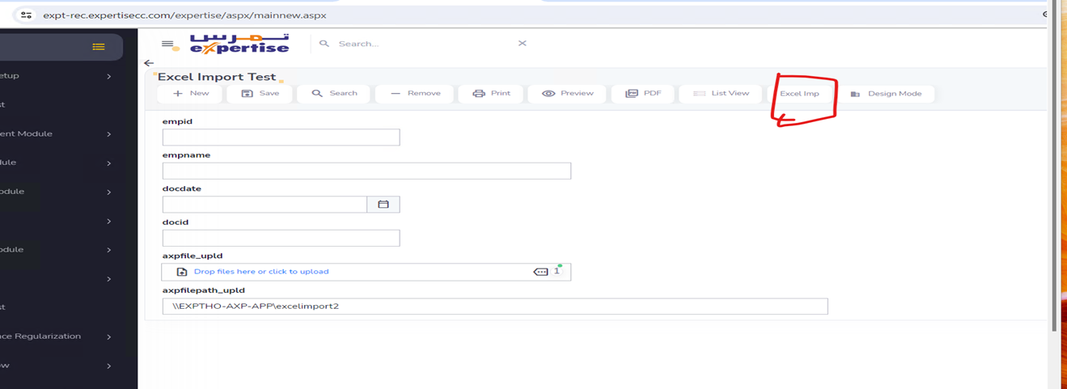

Step 4 image

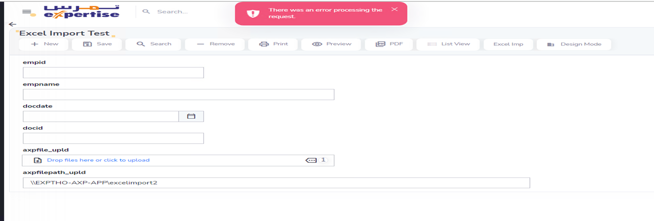

Step5 image

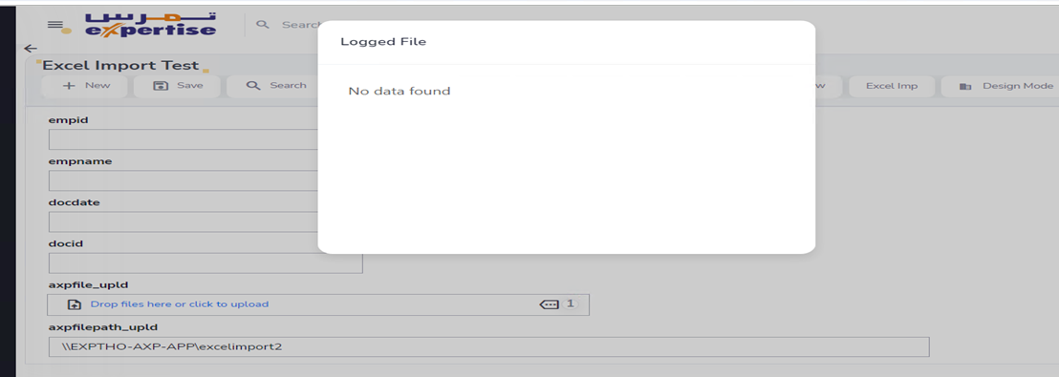

Process 2

-------------------

In training we got below steps for csv import.

Step1 Hear we created axpfile_upld, axpfilepath_upld, script.

Step2 As per path we placed the csv file and Success and Fail Folders.

Step3 If we are trying to import then no records are imported and for trace file please find the attachment.

