Before saving the structure:
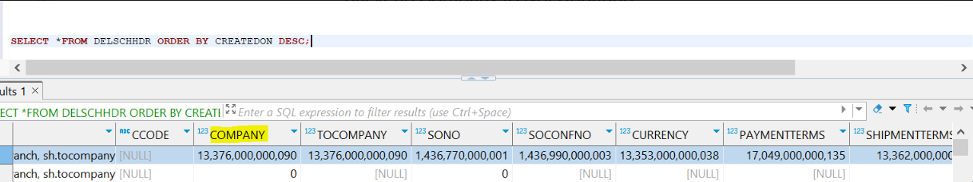

After saving the structure:

