1. After submitting the screen, it fails to refresh.

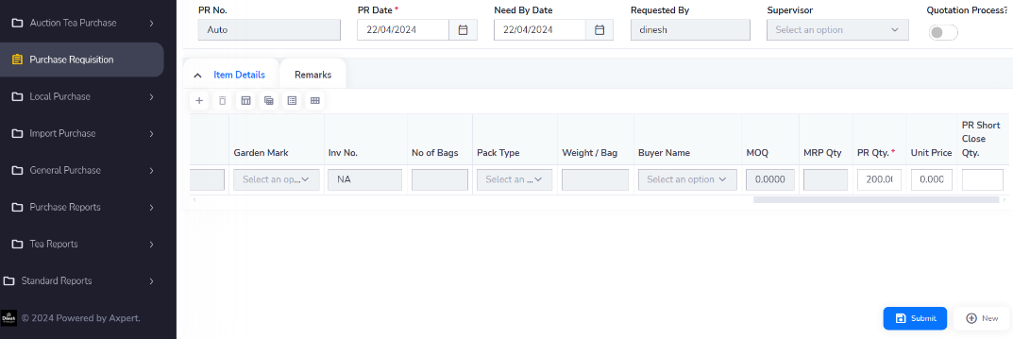

1. Clicking the 'New' button fails to initiate its intended action.

