Before applying patches screen shot:
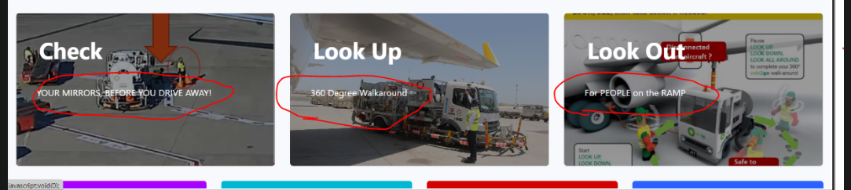

After applying patches screen shot:
