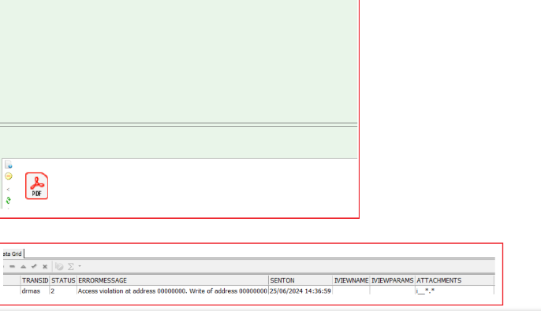

The user found that the latest 9.7 AXE version did not resolve the issue. However, today, they tested it with version 10.9 AXE, and it is functioning correctly. Please assess if the same solution can be applied to 9.7 AXE, as they plan to continue using this version for the next few months.