**Point no. 1:**

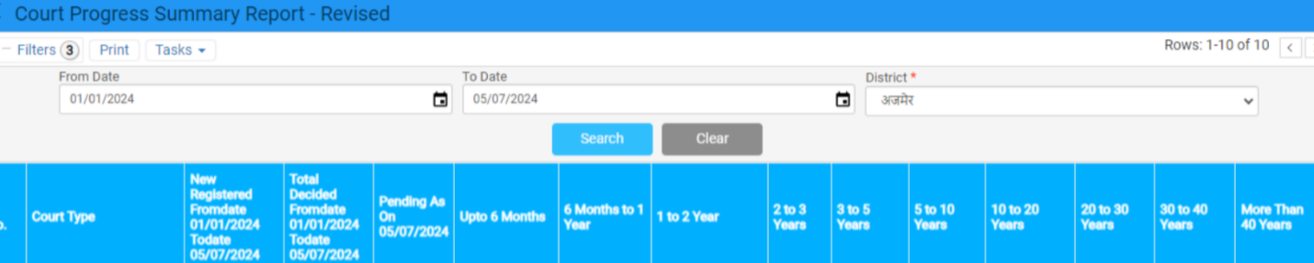

**Point no. 2:**



**Point no. 3:**

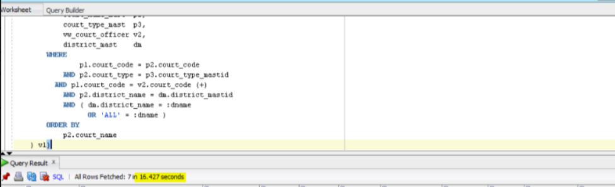

**Staging Environment:**

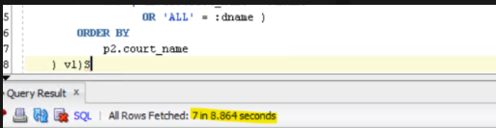

**Point no. 4:**

