This is an example from Tea Trends Web Version. When we click on Developer Option, we can view the below screen.

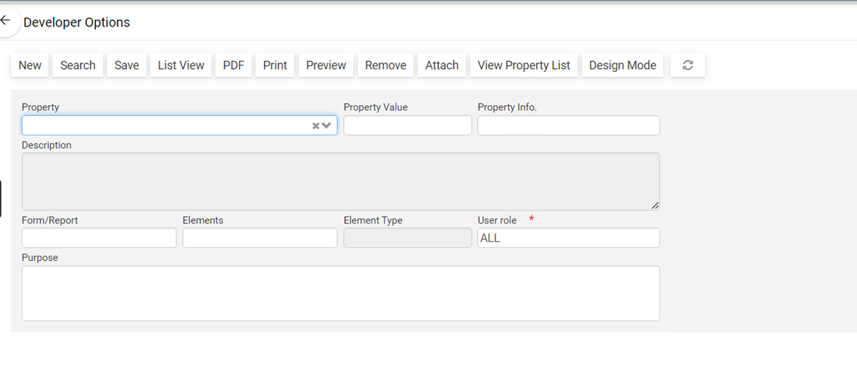

But when it comes to the Lankem, we get the below error. That’s why we requested from you to enable the Developer Option.

