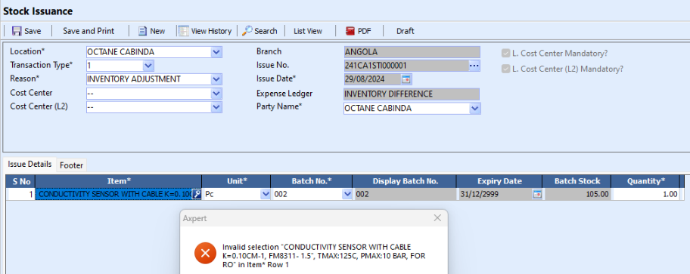

Trace file :  
<https://drive.google.com/file/d/1f3W5RMfWEX4MNjR8A4mocITMYsszIDcs/view?usp=sharing>