**Login with Axpert**

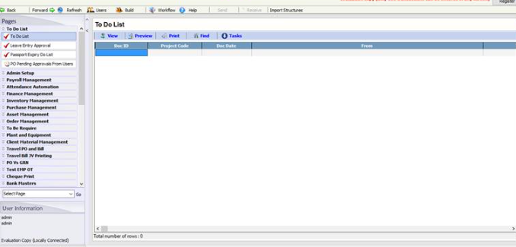

**while trying to upgrade with 8.9 axpert manager exe**

