**Screenshot 1:**

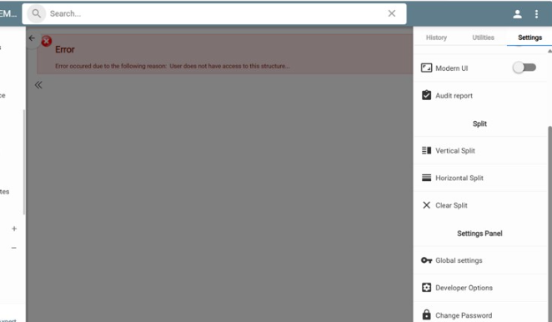

This is an example from the Trends Web Version. When we click on the Developer Option, we can view the below screen.

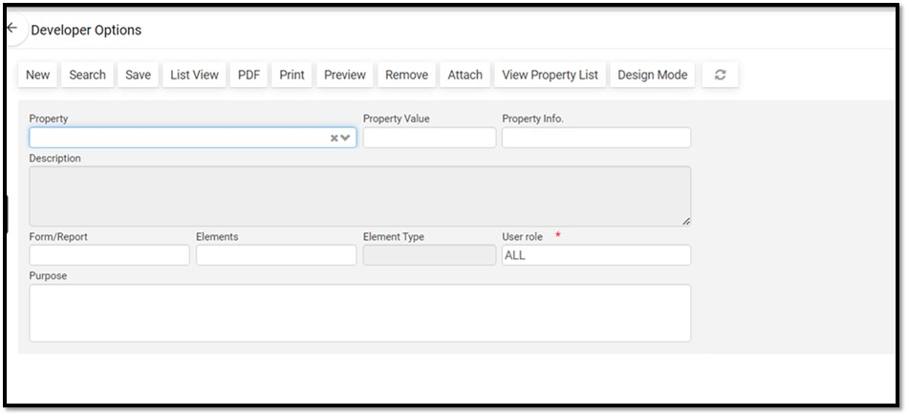

We get the error below. That’s why we requested that you enable the Developer Option. Also, please note that we tried with the default user, Admin. But still getting the same issue.

