·        Pre-registration Admin **(available in desktop)**

·        Add/Drop Subjects **(available in desktop)**

Pre-registration Admin **(available in desktop)**

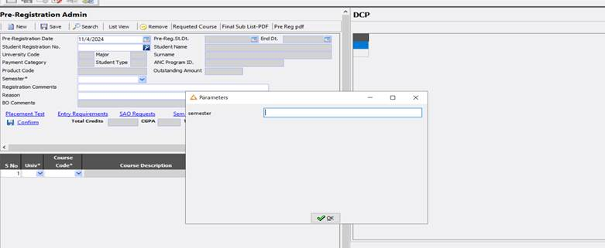

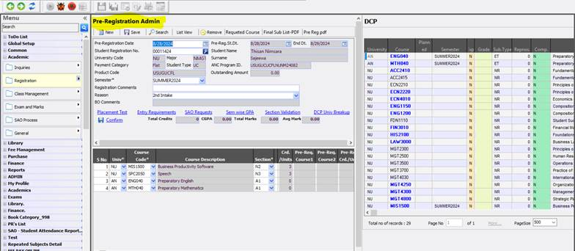

Add/Drop Subjects **(available in desktop)**

