Error popup  when I’m using Date: 31/12/9999



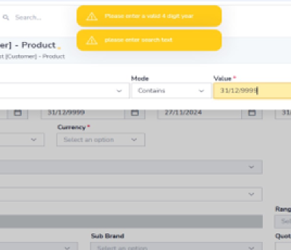

Error popup, while I’m using date in contains mode:

  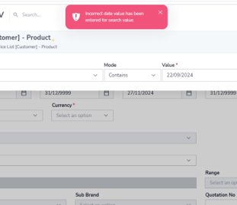

On the desktop version, we are able to successfully retrieve data using the date 31/12/9999

